INDIAN SCHOOL AL WADI AL KABIR

Class: XI Comp. Sci. | Department: Computer Science | Date of submission: 08/08/2023
Try all the programs on your PC | Holiday Homework | Note: Answer all these questions in the note book

1. Do the following :

1) (1 1 1 1)₂ = ( ____________) ₁₀
2) (1 0 0 1 1 )₂ = ( _______ )₈
3) (265)₈ = ( _______ )₁₀
4) (ACB)₁₆ = ( _______ )₁₀
5) (B6C)₁₆ = ( ______ )₂
6) (11001101011010)2 = ( ______ )₁₆
7) (675) ₈ = ( _____________) ₁₆
8) (923)₁₀ = ( _______________) ₈
9) (3454)₁₀ = ( _____________) ₁₆
10) (BCD)₁₆ = ( _____________) ₈
2. Prove using truth table:
a. X(X +Y) = X
b. X + X’Y = X + Y
c. X+ YZ = ( X + Y ) ( X + Z)
3. State and prove DeMorgans theorem.
4. Give the expression for the following circuits.
a.
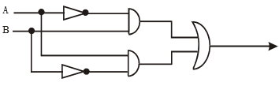
b.
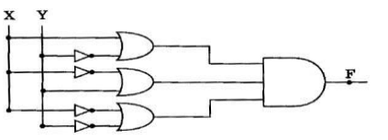
5. Draw the logic circuit for the Boolean expression:
i. F=AB’ +(CD)’
ii. F=A’B + AC’+BAC
6. Do the following:
- Write a program to convert distance in Meters to Kilometer and Meter.
Hint: If Input Meters = 7840, then output = 7 KM and 840 M
1 KM = 1000 Meters
- Write a program to calculate and Compound Interests.
A = P x (1+R/100)^{t}
Compound Interest = A – Principal Amount
P – Principal Amount A – Amount R – Rate T – Time Span
- Write a program to calculate the solutions for a Quadratic Equation.
d = b² – 4 x a x c
Root1 = - b + Sqrt(d) / ( 2 x a)
Root2 = - b - Sqrt(d) / ( 2 x a)
- Write a program to convert Kilometers into Miles.
Miles = Kilometers * 0.621371
- Write a program to calculate Celsius to Fahrenheit.
Fahrenheit = (Celsius x 1.8) + 32
6) Write a program to input a number and print its multiplication table.
7) Write a program to find the sum of first 20 odd numbers.

